**CWL Newsletter September 2018 Newsletter**

The Legion of Mary, Our Lady of the Rosary is a prayer group meeting at St Charles on Wednesdays at 7PM and welcomes you to join them.

**Save the Date**

*Cookie Making Bee*

*There will be a cookie baking bee at the church on Thursday, October 11.*

*This is in preparation for the Bazar. Call Sandy at 780-456-3009 to let her know so she will now how many people to expect.*

*Thank you for supporting the CWL Fall Bazar*

Next CWL meeting Tuesday, October 16, 2018

Fall Bazaar Saturday, October 20, 2018 Katherine Tarras is convening

A Screening of Over 18 on Wednesday, November 21, 2018

CWL Elections will be held on January 22, 2019 meeting at 7PM

Pasta Supper Saturday, January 26, 2019 Rose Hearn is convening

National Convention is in Calgary in 2019

St Chalres will be hosting the World Day of Prayer on March 1, 2019. The host country is Slovania so if you have any connection or artifacts from this country please contact Kathy Martel who is conveening and thank you to Lori for co-conveening.

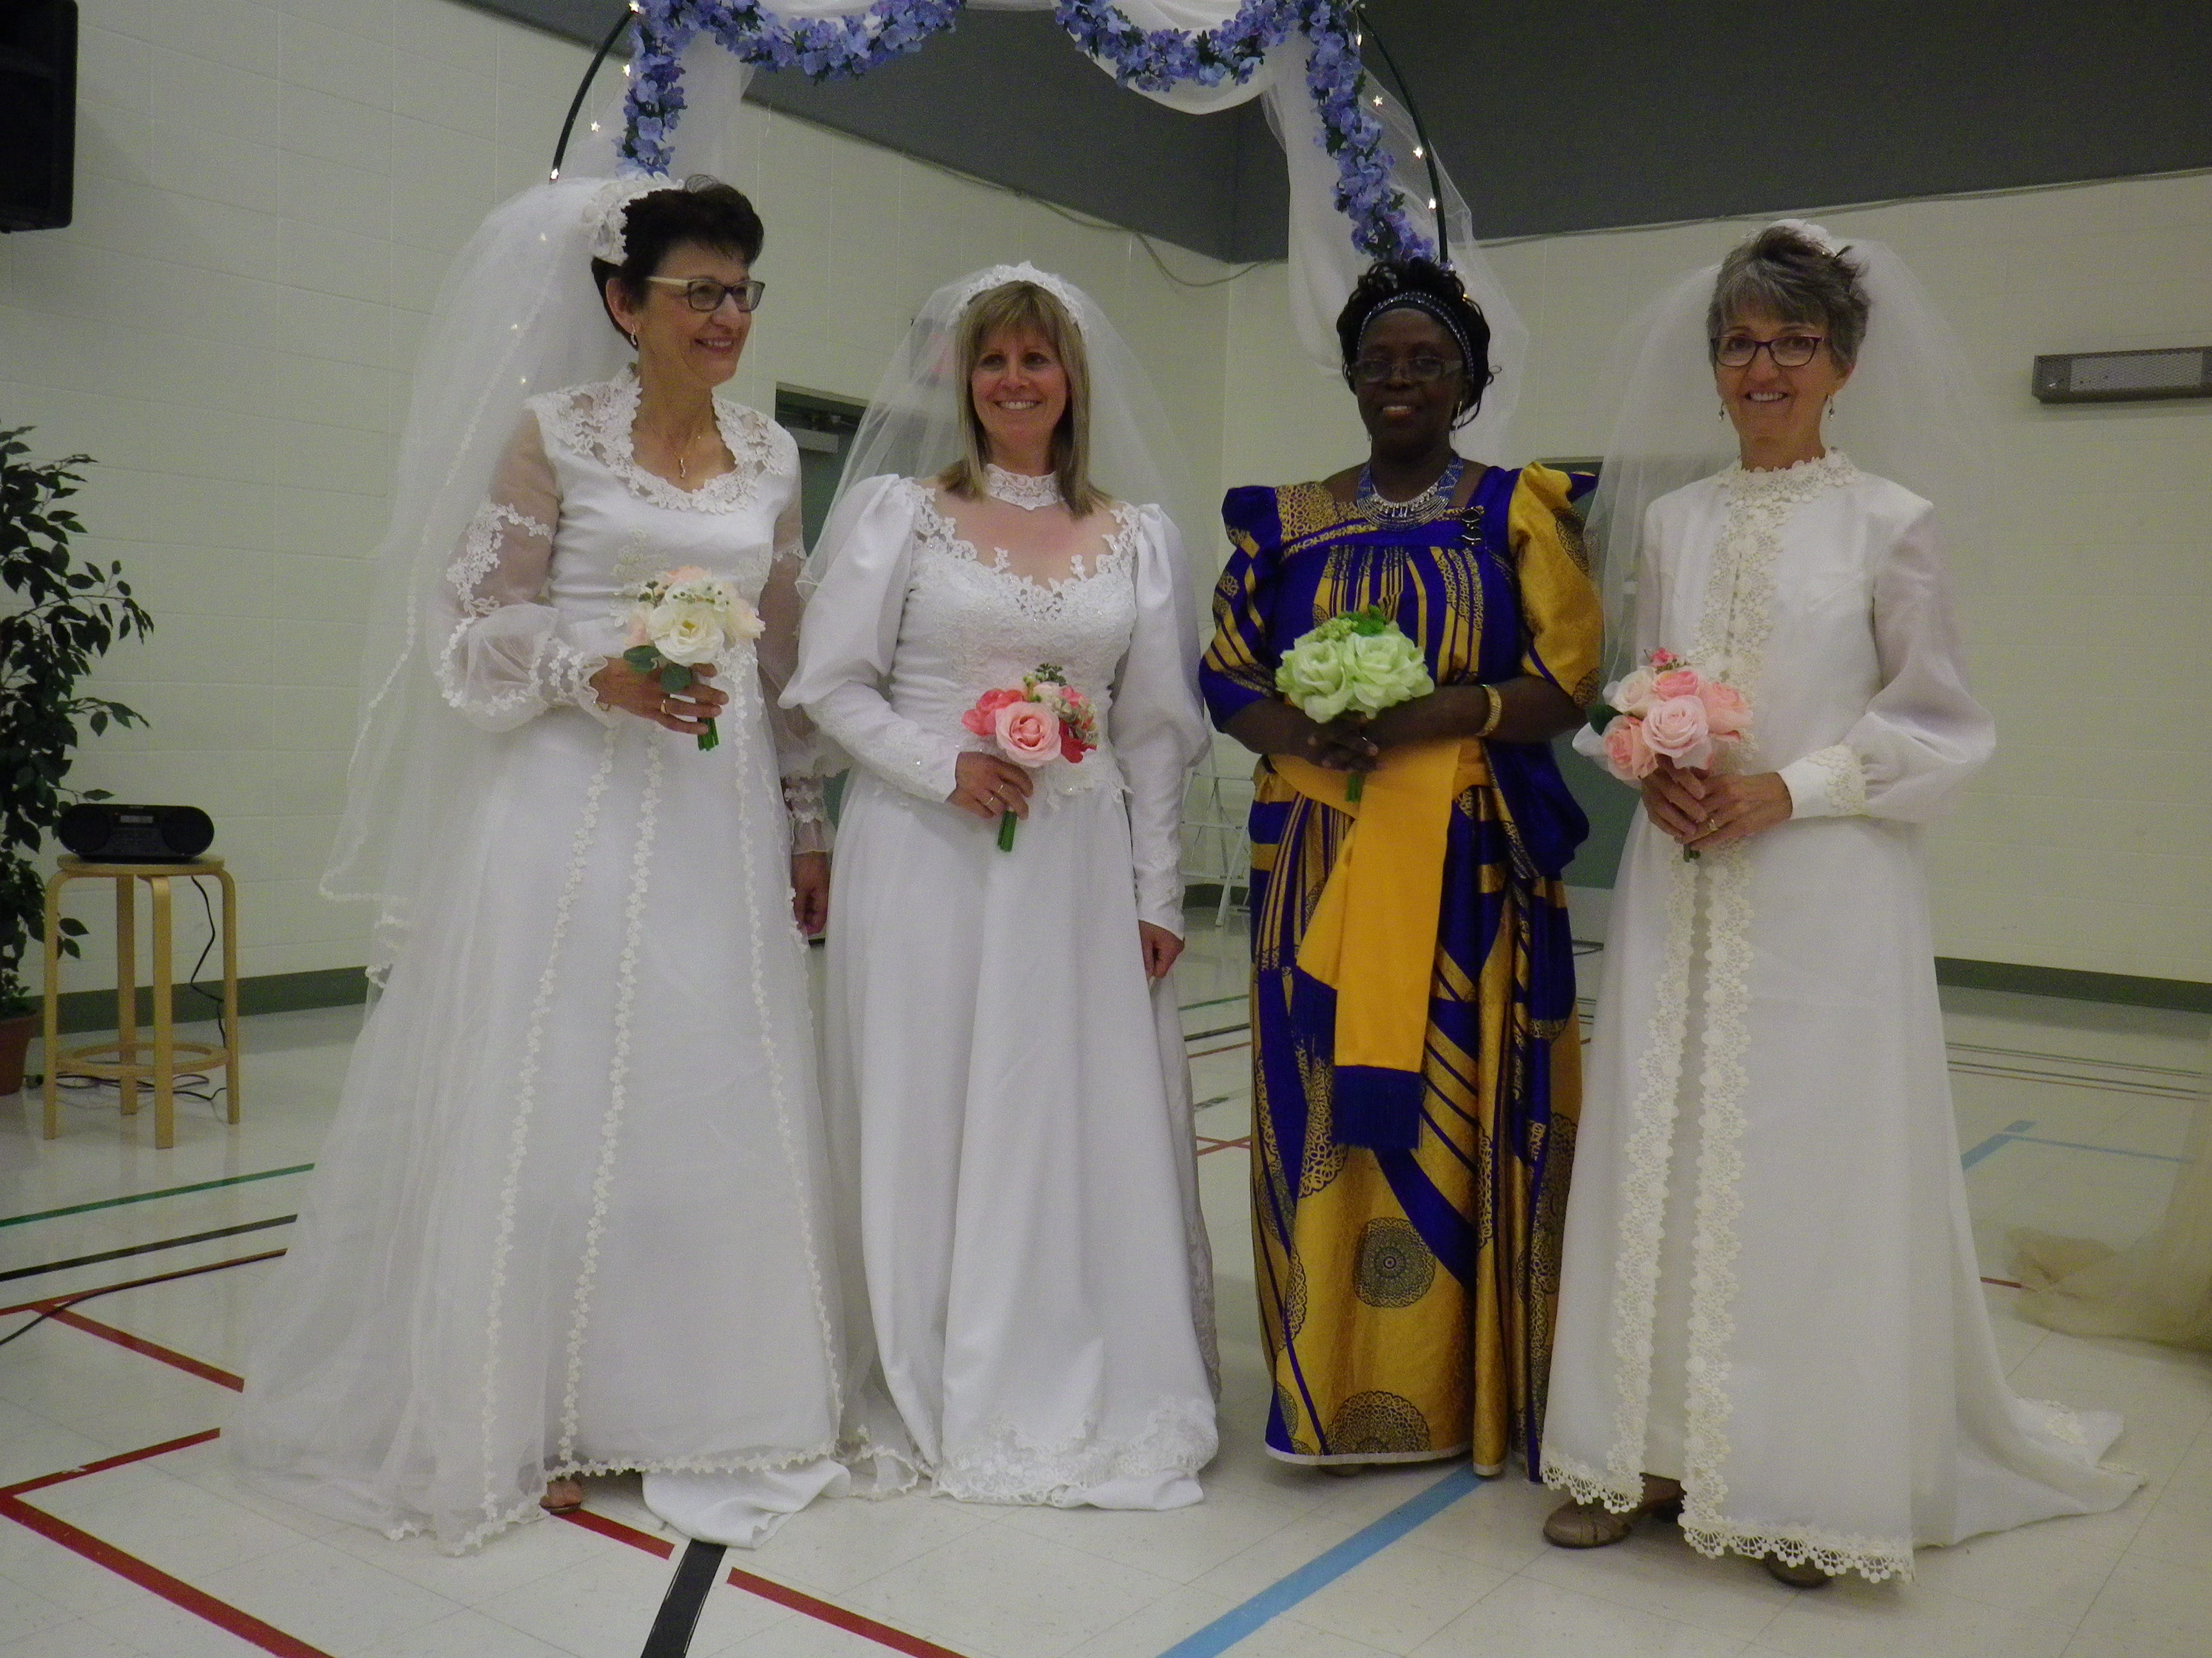

Lovely picture of CWL members Bev Jensen, lovely model in Katherine Tarras’ dress, Annet Maitwe (traditional Uganda wedding dress) and Connie McBride modeling their wedding dresses at the June Social.

Hamburger soup and carrot cake making will be on October 2, 2018 at 9AM.

Cookie Bake will be at 9AM on October 11, 2018. If you haven’t signed up for the Fall Bazaar we are looking for volunteers for selling raffle tickets after church and at the raffle ticket table at the Bazaar.

Magdalene House is a shelter outside of Edmonton that is a recovery house for those previously in the sex trade industry. We will have a table of fair trade items for sale and the money will be donated to Magdalene House.

Canadian Mental Health Association in Edmonton has resource material available for download: edmonton.cmha.ca

ST. CHARLES CWL PRAYER LIST

September 2018

Please pray for our CWL members

and our council

For those who are sick and all those who look after them:

For those who have died and all who mourn them:

Hilda Daubner’s Huband Ludi Daubner

Connie McBride’s Brother-In-Law Peter Muller

Rita Pfefferle’s nephew Marc Renaud